STAFF APPRECIATION AND RECOGNITION (STAR)

Berkeley STAR Nomination Form

Name of Nominee: |  |  |  |  |  |  |  |  |  | Employee ID:
Job Title: |  |  |  |  |  |  |  |  |  | Job Title Code:
Unit/Department Name:

Type of Award: Achievement Award Spot Award
Provide a brief description (1-3 paragraphs) of the specific reason for nomination and linkage to one or more of the UC Berkeley Operating Principles. If nomination for an Achievement Award, describe the sustained, exceptional performance aspects that warrant an Achievement Award. If the nomination is for an employee in another unit, please consult with the employee’s home unit regarding how the award cost will be covered.

Eligibility for award (both boxes must be checked):
The nominee is a non-represented employee or a represented employee in the Clerical (CX) represented bargaining unit.
The nominee has a rating of “meets expectations” or above and has no outstanding disciplinary actions.
Nominator Name: |  |  |  |  |  | Signature: |  |  |  |  | Date: |  | mm/dd/yyyy
(For Achievement Award, usually Employee’s Supervisor or Manager)
Nominator’s Unit: |  |  |  |  |  | Contact address:
E-mail address: |  |  |  |  |  | Phone:
Supervisor: (if other than Nominator) |  |  |  |  |  | Signature: |  |  |  |  | Date:
Next Level of Authority
Name: Signature: Date:

VC or Dean (only required for Achievement Awards)
Name: |  |  |  |  |  | Signature: |  |  |  |  | Date:
Office Use Only:
Award Approved  Award amount:  (copy to be placed in nominee’s Personnel File) |  |  |  |  |  |  | Guidelines:  $2,000-$10,000 for Achievement Award (less taxes) (if a team award is provided each member receives $1,000)  $500 for Spot Award (less taxes)
Achievement Award Denied, but approved for Spot Award
Award amount:
Reason for change from Achievement Award to Spot Award:

Award Denied
Reason for Denial:

Recognition Award Administrator Name: |  |  |  |  |  |  | Signature:
Job Title: |  |  |  |  |  |  | Date:
June 2015
Please complete this form and return to your Recognition Award Administrator.

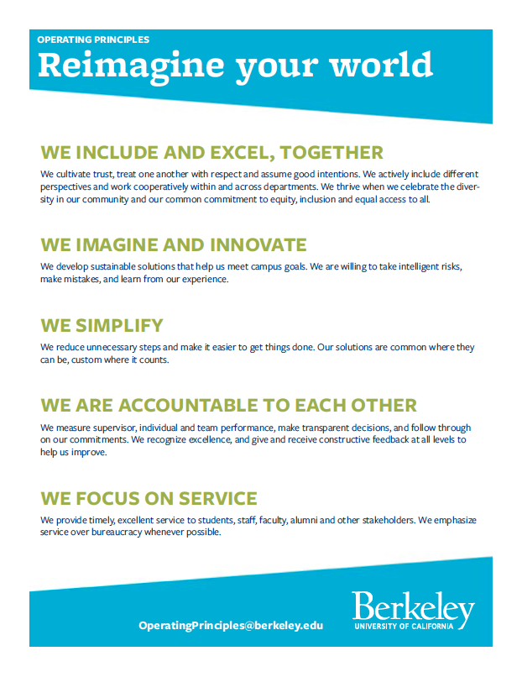
Berkeley Operating Principles

Examples of Distinctions between Achievement Awards and Spot Awards

Spot Awards  “In-the-moment contributions” | Achievement Awards -  “Substantial change over time”
- We include and excel, together  Example: Instead of updating a lobby directory for just one department, an Administrative Assistant reaches out to all the building's occupants to gather their updates, resulting in a better, more inclusive sign.  - We imagine and innovate  Example: Student Services Advisor creates a comprehensive, informative matrix on the college website of financial aid sources for students, including eligibility criteria and other pertinent factors.  - We simplify  Example: A team of Financial Analysts works within a college over a short period of time to develop a standard budget process for a department within the college. Good leadership and teamwork results in a successful outcome.  - We are accountable to each other  Example: Human Resources Manager creates a culture for continuous feedback in the workplace by encouraging staff to mentor each other, recognize each other’s achievements, and offer constructive solutions when things aren’t going well.  - We focus on service  Example: Financial Analyst enrolls in a class to increase her financial modeling knowledge and, as a result, makes improvements in the financial modeling process in her department. | - We include and excel, together: resulting in the accomplishment of significant departmental or divisional goals and objectives  Example: Project/Policy Analyst drafts an insightful, comprehensive proposal and assists with implementation to reconfigure the units within the Library, thereby breaking down silos, and enhancing resource sharing while retaining the specific functions of each library unit.  - We imagine and innovate: resulting in one-time or sustained time/dollar/environmental savings, revenue enhancement, productivity improvement; and/or ongoing innovative/creative activities that benefit organizational systems, protocols, and/or procedures.  Example: Applications Programmer facilitates the replacement of the unit’s legacy system by modifying and enhancing an application from another campus unit. The modified system improves and secures systems operations and costs significantly less than projected replacement costs.  Example: External Relations Specialist takes responsibility for her professional development and keeps abreast of best practices in external constituent outreach through continuing education. She conceives, designs, and implements an innovative method to identify and contact alumni who have a high probability of supporting UC Berkeley, with significant impact for both fundraising and political support for the campus.  - We simplify  Example: Student Services Advisor leads the design and implementation of a program that developed valuable information, streamlined processes and systems for supporting students and their well-being. This work is not only enthusiastically adopted by the Berkeley Campus, but has become a go-to model of the UC System as a whole.

